MTH 337
Report 4
Plotting Data
Floating Point Numbers
by Tejas Vyas

Plotting Data

INTRODUCTION
To analyze numerical data, often we need to process it further such that it is easier to handle. We're using NumPy library here to learn file processing and direct array handling to process and display a big chunk of publicly available data on Balloon experiment performed by NASA on August 5th. Basically, we're watching how the balloon temperature goes against time passed in this experiment.

ASSIGNMENT DETAILS
We're taking the data provided by NASA's LARC station, changing the file-type, importing it into Python, and using NumPy functions, process the data so that we can get plot temperature against time and look the behavior of the balloon.

PROCEDURE
We start with downloading the data file to our computer and placing it at a Path where Python can access it. We also change it's file-type from a simple text file to a dat type file so that Python can traverse it easily.
Now, after importing NumPy in the scenario, we can use the built in loadtxt() function and set as argument the given file. We can also skip the top few rows so that we only get the table of values which we can directly import as multiple arrays. We use the skiprows argument inside the loadtxt function for that.
Our algorithm to generate graphs after this is pretty straight forward as NumPy gives us direct array access and also provides us a way to easily easy modify the array.
Here's our algorithm:
function plottingData (input file, rowsToSkip){
Use Loadtxt to load inputfile and skip the rowsToSkip number of rows
set minutes, temperature and time by simply referencing the columns and making seperate arrays
get a more compact time parameter by combining mins and seconds array to a more precise “time” array
generate graph using plot function
}

To get out compact time array, we're simply converting the amount of seconds to float minutes and adding it to original minutes array. NumPy lets us do element wise operations on the array which makes the code simply: time = mins + secs/60.
Our results are presented below with a brief idea of how the altitude of balloon affects temperature of the system as time passes.

RESULTS
These are our respective arrays:
Minutes: [ 0. 0. 0. ..., 34. 34. 34.]
Seconds: [ 0. 1. 2. ..., 8. 9. 10.]
Temperature: [ 27.5 27.4 27.3 ..., -30. -30. -30.1]
Time: [ 0.00000000e+00 1.66666667e-02 3.33333333e-02 ..., 3.41333333e+01 3.41500000e+01 3.41666667e+01]
Altitude: [ 11 ..., 9460]

ANALYSIS and CONCLUSION
Below is the graph we generate after placing temperature against time.
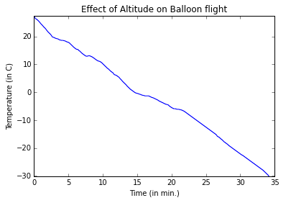
We can clearly see above that the temperature of the balloon decreases almost linearly with time as the balloon increases in altitude.
This data may be used to analyze the temperature in the troposphere for the current experiment. Since the maximum altitude gained is 9460m or 9.46 km, we're almost at the final part of troposphere and thus the temperature is low because as we move farther from the surface of the earth the sunlight and heat trapped by oceans and radiated becomes less which in turn decreases the temperature.

SOURCE CODE

import math
from pylab import *

def plottingData(inputFile,rowsToSkip):
'''returns plot of certain columns in the given data file after skipping a number of rows.'''
data = loadtxt(inputFile,skiprows = rowsToSkip)
mins = data[:,0]
print "Minutes: ",mins
secs = data[:,1]
print "Seconds: ",secs
temp = data[:,5]
print "Temperature: ",temp
time = mins + secs/60.
print "Time: ",time
plot(time,temp)
ylim(-30.1,27.5)
xlabel("Time (in min.)")
ylabel("Temperature (in C)")
title("Effect of Altitude on Balloon flight")

plottingData("balloon.dat",138)
Floating-Point Numbers

INTRODUCTION
Floating Point numbers for us are basically just the decimal numbers between two integers. In our numerical system, it's fairly easy to represent floating point numbers. However, for a computer, this task is almost impossible because of space and representation constraints.
IEEE 754: Standard for Binary Floating-Point Arithmetic governs a standard idea for representing the floating point numbers using the scientific notation and dividing it into 3 parts: sign-bit, exponent and mantissa so that maximum amount of bits may be represented based on our 32 or 64 bit computers.
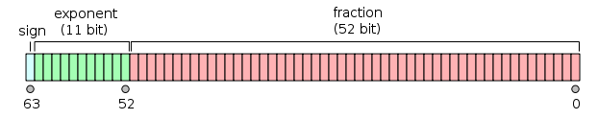
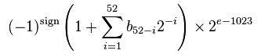
This is how the 64 may be represented according to the standard. Numerically this is given as:
Analyzing these numbers provides us a great insight into the limitations of computing and how we work around them get the most optimized results.

ASSIGNMENT DETAILS
In this part of the assignment, we are trying to find the following in Python:
- The "machine epsilon" (the smallest number that, when added to 1, gives a result greater than 1).
- The largest floating point number that can be represented in Python.
- The smallest floating point number that can be represented in Python.
- The number of bits reserved for the mantissa.
- The number of bits reserved for the exponent.
- The bias used for the exponent.
- Is denormalization used?

To do this, we will be performing computations until the system breaks down and gives us an answer rounded up to a certain level.

PROCEDURE
We start with finding the machine epsilon which is basically the minimum number which when added to 1 returns number higher than 1. Any entity smaller than this will not be able to round the number to the next number. Thus this may be taken as the maximum relative error. Our algorithm to extract the Machine Epsilon is as follows:
def machineEpsilon(type of float): #floats may be 32 bit or 64 bit
let epsilon = 1
while epsilon + 1 != 1
set prev epsilon as temporary var
continue halving epsilon
return the temporary var as epsilon
Next we move forward and begin going further into the floating point numbers. To get the largest floating point number representable in Python, we recursively keep making a number larger. We use the following algorithm:
def maxFLoatingPoints():
let a = 1
while a != infinity
mark b as previous a
add 10% to a
return b
Similarly, we can also get the smallest floating point number by continuously making a number smaller. Here's the algorithm:
def minFLoatingPoints():
let a = 1.0
let b = 2*a
while b > a > 0
mark c as previous a
continue halving a
return c
In order to get the mantissa and exponent, we need Python to represent a number with the maximum bits it can handle. We start with the mantissa and use an irrational number to get the number of decimal points it can handle. Unfortunately, Python continues rounding the numbers to single precision point (or 10 bits) so we use the inbuilt Decimal library to make sure Python gives us the full value. Since we know the double precision system is 64 bits and 1 bit is used for sign (-ve or +ve) we can simply subtract mantissa from 64 -1 to get the number of exponent bits Python can handle.
Here's our algorithm:
def bitCounter():
let array = decimal(sqrt(2))
len(array after decimal point) = mantissa
Exponent = 64 – 1 -mantissa
return exponent and mantissa
Now we calculate the bias used for exponent. This is simply the range where the exponent may be represented. Thus, we can use the number of bits exponent has at max, change it to the power of 2, divide it into two parts (positive and negative) and we will get our bias. Here's our algorithm:
def biasCalculation():
minimum bias = (2^(exponent) – 1)/2 -1 #to get the negative part
maximum bias = (2^(exponent) – 1)/2 +1 # to get the positive part
return minimum and maximum biases

Now finally, to get whether our experimental calculations were subject to denormalization, we use the NumPy library to get the actual limits of biases, exponent, mantissa and floating point numbers. If it is not same as our calculations, our experimental values were denormalized. The following function gives us the table for all values we seek: numpy.finfo(numpy.float)

RESULTS AND ANALYSIS
Here are our results:
- Maximum Floating Point: 1.78371873262e+308
- Minimum Floating Point: 5e-324
- Machine Epsilon (64-bit): 2.220446049250313e-16
- (32-bit): 1.1920929e-07
- Mantissa: 52
- Exponent (64-Mantissa-SignBit): 11
- Min Exp Bias is: 1022
- Max Exp Bias is: 1024
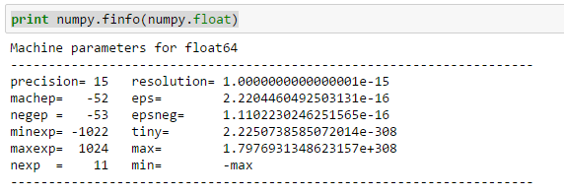
and here are the actual values:
It is clear that even though our machine epsilon, bias and bit usage was the same, our max and min floating point numbers were different, and thus denormalization was used here.
It's also worth noting that we having our minimum float < actual minimum float. This is because of the bits used. Actual calculations use 16 bits for the decimals while we have none. Rounded after 308 it makes our exponent 308+16 = 324.

SOURCE CODE
import math
from pylab import *
from decimal import *
import numpy as numpy

def maxFloatingPoint():
'''Returns Max Floating Point number'''
start = 1.0
while not math.isinf(start):
res = start
start = start*1.1
print res

def minFloatingPoint():
'''Returns Min Floating Point number'''
start = 1.0
res= 2.0*start
while res > start > 0:
res = start
start = start*0.5
return res

def machineEpsilon(func=float): #it accepts float, float-64 and float-32
'''Returns Machine Epsilon'''
ep = func(1)
while not (func(1)+func(ep) == func(1)):
res = ep
ep = func(ep) / func(2)
return res

def bitCounter():
'''Returns Mantissa and Exponent bits'''
counterArray = str(Decimal(math.sqrt(2)))
print (Decimal(math.sqrt(2))), math.sqrt(2)
print 'Mantissa: ', len(counterArray[2:])
print 'Exponent (64-Mantissa-SignBit): ', 63-len(counterArray[2:])
res = [1,63-len(counterArray[2:]),len(counterArray[2:])]
return res

def biasCalculation():
'''Returns min and max biases'''
min = ((2**11)-1)/2 - 1
max = ((2**11)-1)/2 + 1
print 'Min Exp is: ', min, 'Max Exp is: ', max
return min,max

maxFloatingPoint()
minFloatingPoint()
machineEpsilon(float)
machineEpsilon(numpy.float64)
machineEpsilon(numpy.float32)
bitCounter()
biasCalculation()
print numpy.finfo(numpy.float) #Our base for getting actual values.

